
DEPARTMENT OF

COMPUTER

Experiment 5
Student Name:Riya Kashyap UID: 25MCA20033
Branch: MCA-UIC Section/Group: 1
Semester: 2nd Date of Performance:24/2/2026
Subject Name: Technical Training Subject Code: 25CAP-652

- Aim:To gain hands-on experience in creating and using cursors for row-by-row processing in a database, enabling sequential access and manipulation of query results for complex business logic.
- Objective
- Sequential Data Access: To understand how to fetch rows one by one from a result set using cursor mechanisms.
- Row-Level Manipulation: To perform specific operations or calculations on individual records that require conditional procedural logic.
- Resource Management: To learn the lifecycle of a cursor: Declaring, Opening, Fetching, and importantly, Closing and Deallocating to manage system memory.
- Exception Handling: To handle cursor-related errors and performance considerations during large-scale data iteration.
- Theory:
While SQL is generally set-oriented, certain tasks require a procedural approach where we process one row at a time. This is where Cursors are used:
Cursor Types: Cursors can be Implicit (managed by the system) or Explicit (defined by the developer). They can also be Forward-Only (moving only toward the end) or Scrollable (moving back and forth).
The Lifecycle: * DECLARE: Defines the SQL query for the cursor.
OPEN: Executes the query and establishes the result set.
FETCH: Retrieves a specific row into variables for processing.
CLOSE: Releases the current result set.
DEALLOCATE: Removes the cursor definition from memory.
Use Case: Cursors are ideal for generating row-specific reports, updating balances based on complex historical data, or migrating data where each record needs individual validation.

- Procedure of the Practical:

Table creation
--STEP 0->Create employee table

DROP TABLE IF EXISTS employee;
CREATE TABLE employee (
emp_id SERIAL PRIMARY KEY,
emp_name VARCHAR(50),
salary NUMERIC,
experience INT,
performance_score INT
);

INSERT INTO employee (emp_name, salary, experience, performance_score)
VALUES
('Aman', 30000, 2, 3),
('Riya', 40000, 5, 4),
('Karan', 50000, 8, 5);

Step1- Simple Forward-Only Cursor

DO $$
DECLARE
emp_record RECORD;
emp_cursor CURSOR FOR
SELECT emp_id, emp_name, salary FROM employee;
BEGIN
OPEN emp_cursor;
LOOP
FETCH emp_cursor INTO emp_record;
EXIT WHEN NOT FOUND;
RAISE NOTICE 'ID: %, Name: %, Salary: %',
emp_record.emp_id,
emp_record.emp_name,
emp_record.salary;
END LOOP;
CLOSE emp_cursor;
END $$;

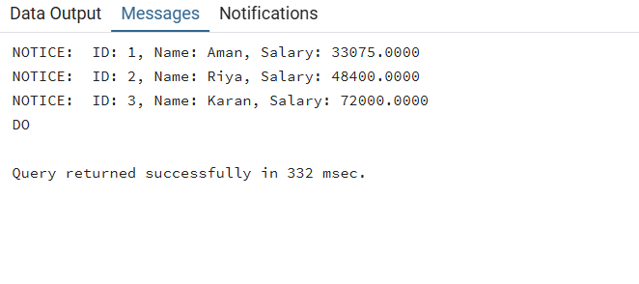

Step 2: Complex Row-by-Row Manipulation

DO $$
DECLARE
emp_record RECORD;
emp_cursor CURSOR FOR
SELECT emp_id, emp_name, salary, experience, performance_score
FROM employee
FOR UPDATE;
BEGIN
OPEN emp_cursor;

LOOP
FETCH emp_cursor INTO emp_record;
EXIT WHEN NOT FOUND;
RAISE NOTICE 'Before Update -> ID: %, Salary: %',
emp_record.emp_id,
emp_record.salary;
IF (emp_record.experience * emp_record.performance_score) > 30 THEN
UPDATE employee
SET salary = salary * 1.20
WHERE CURRENT OF emp_cursor;
ELSIF (emp_record.experience * emp_record.performance_score) > 15 THEN
UPDATE employee
SET salary = salary * 1.10
WHERE CURRENT OF emp_cursor;
ELSE
UPDATE employee
SET salary = salary * 1.05
WHERE CURRENT OF emp_cursor;
END IF;
END LOOP;
CLOSE emp_cursor;
RAISE NOTICE 'Salary Update Completed!';
END $$;

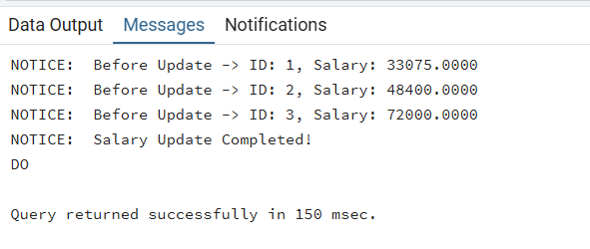

Step 3: Exception & Status Handling

DO $$
DECLARE
emp_record RECORD;
emp_cursor CURSOR FOR
SELECT * FROM employee WHERE salary > 10000; -- condition for testing empty result
BEGIN
OPEN emp_cursor;
FETCH emp_cursor INTO emp_record;
IF NOT FOUND THEN
RAISE NOTICE 'No records found!';
ELSE
LOOP
RAISE NOTICE 'Processing Employee ID: %', emp_record.emp_id;
FETCH emp_cursor INTO emp_record;
EXIT WHEN NOT FOUND;
END LOOP;
END IF;
CLOSE emp_cursor;
EXCEPTION
WHEN OTHERS THEN
RAISE NOTICE 'Error occurred: %', SQLERRM;
CLOSE emp_cursor;
END $$;

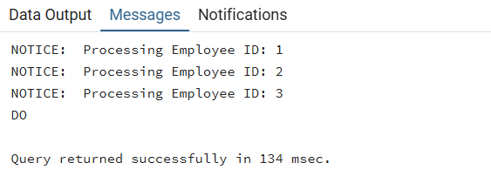

- Learning Outcome:
- Understand the concept and need of cursors for row-by-row processing in PostgreSQL.
- Implement the complete cursor lifecycle: Declare, Open, Fetch, and Close.
- Perform conditional updates and manipulations on individual records.
- Handle exceptions and empty result sets effectively.
- Apply cursor-based logic to solve real-world business scenarios like payroll updates and data validation.

